Jashrelal maya .P

PIR Sensor:

A passive infrared sensor (PIR) is an electronic sensor which is used to detect motion. The sensor measures infrared (IR) light radiating from objects in its field of view. Mainly they have used in PIR based motion detectors.

Piezo Alarm:

Piezo Buzzers and Alarms The piezo buzzer is a watch beeper on steroids. Once exotic and pricey, it is now a useful and ubiquitous commodity. The piezo element itself consists of nothing more than a thin disk of piezo bonded to a thin disk of metal (typically brass, but sometimes stainless steel).

Temperature sensor:

Temperature sensor is a device, used to measure the temperature using an electrical signal. It requires a**thermocouple or RTD (Resistance temperature Detector)**. It is the most common and most popular sensor. Temperature sensor, the change in the temperature correspond to change in its physical property like resistance or voltage.

1. Temperature detection using temperature sensor

Circuit diagram:

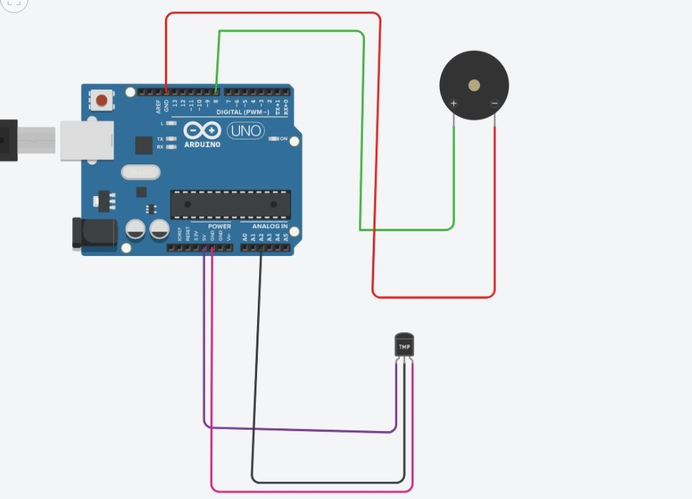

Coding: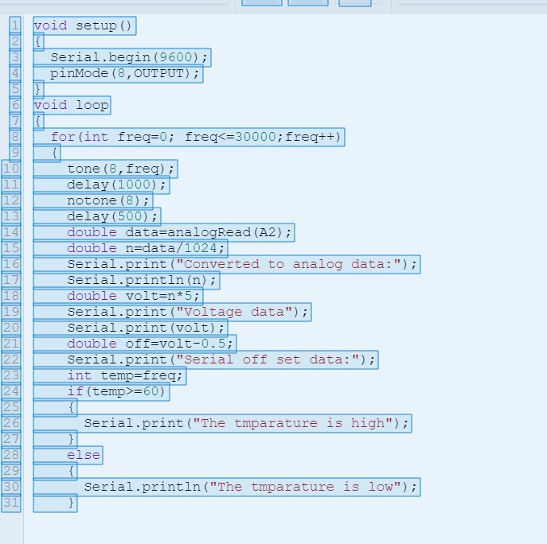

Output:

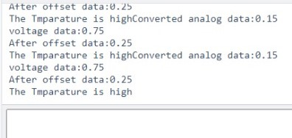

1. Motion detection using PIR sensor

Circuit digram:

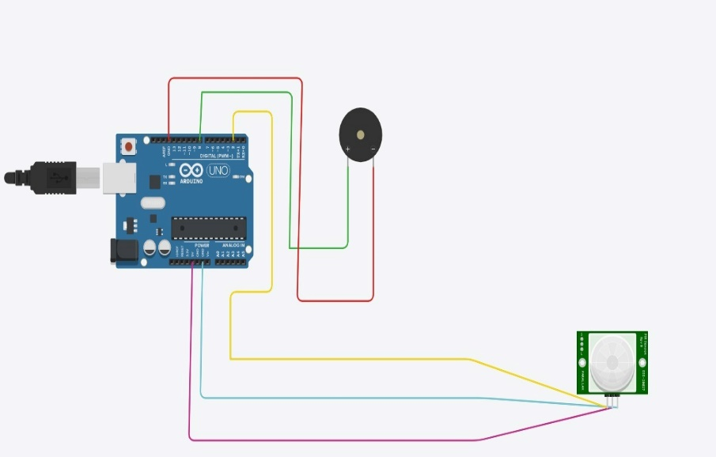

Coding:

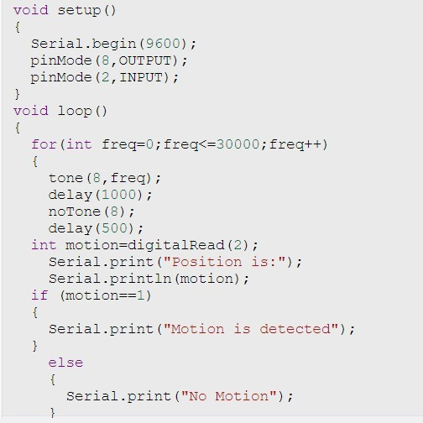

Output:

